Task on terraform -06
1). Watch the Terraform-06 video.
Watched the video -YES
2). Execute the script shown in the video.
Terraform Module
A Terraform module is a reusable package of Terraform code that groups resources together
and can be used multiple times.
Let’s create a directory first called aws_instance
In directory let’s create two files
1. main.tf
2. variables.tf
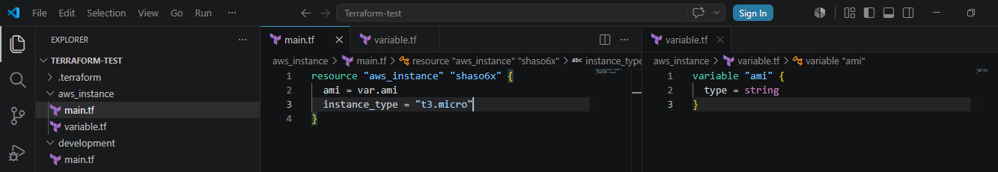Now let’s create another directory called development
In this let’s create another main.tf
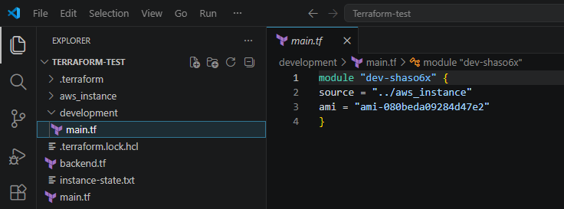Let’s change the directory go to aws_instance directory and lets perform terraform init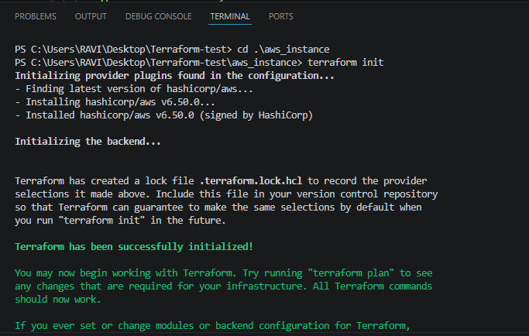
Now let’s execute terraform plan and terraform apply: 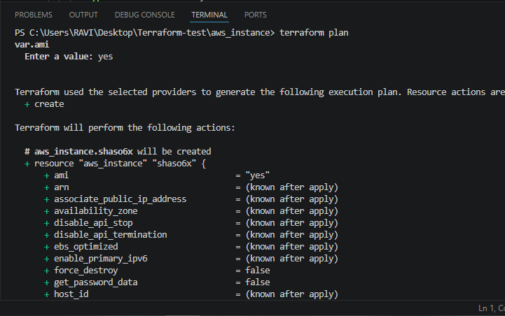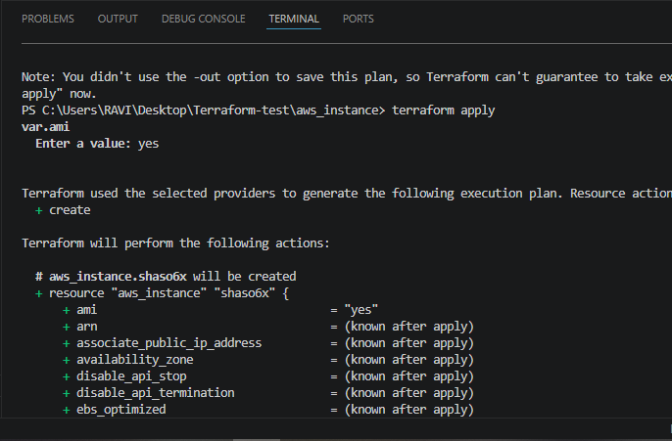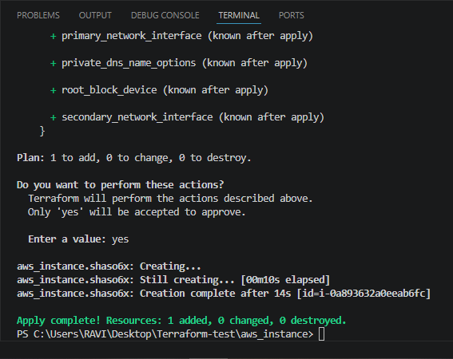
Now we can see terraform.tf file has been created in Development Directory: 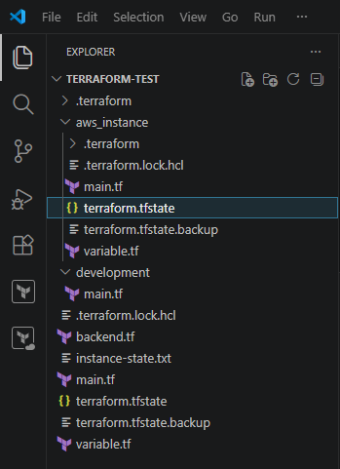
Terraform Workspace
Workspace can be used if we have multiple projects/environments using the same configuration.
Let’s create main.tf and variables.tf files. 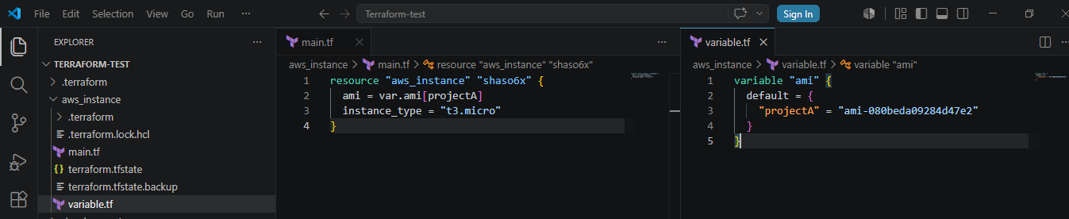For creating workspace
terraform workspace new projectA ⇒ for creating a new workspace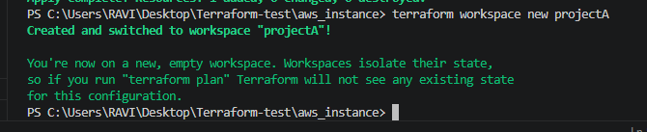We can see the new workspace created in terraform.tfstate.d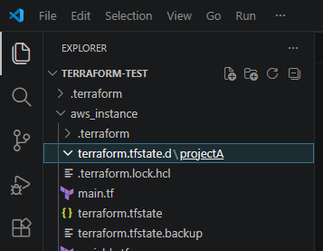
terraform workspace list ⇒ for getting list of workspace: 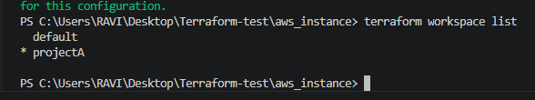terraform workspace selecr projectA to swtich to specific workspace
Lets check if the folder called ProjectA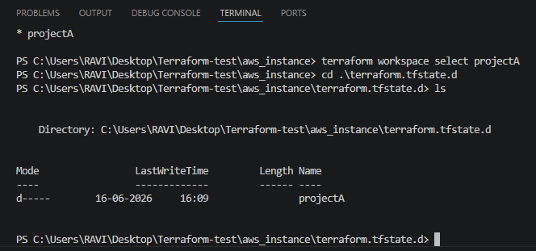
Firstly go one step back with cd .. and then execute this below command:
Lets do terraform init now terraform apply:
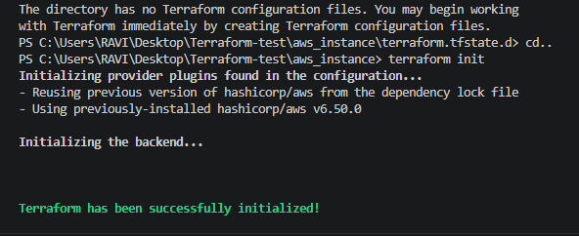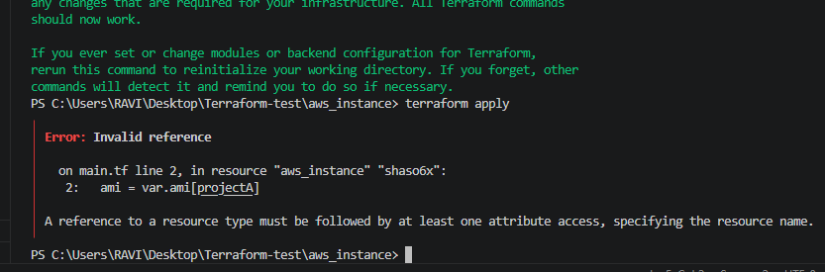
Lets check in aws ec2 if the instance has been created or not:
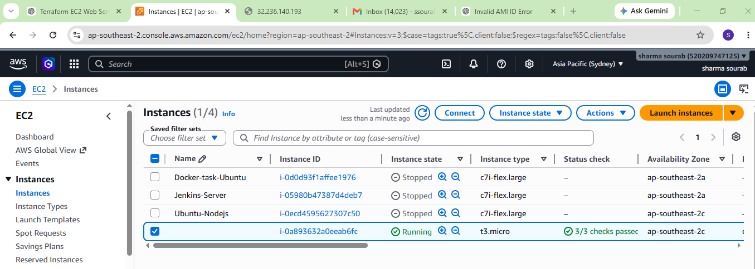
3). Provision EC2, S3, and VPC using Terraform modules.
Lets create folders
mkdir modules
mkdir modules\vpc
mkdir modules\ec2
mkdir modules\s3
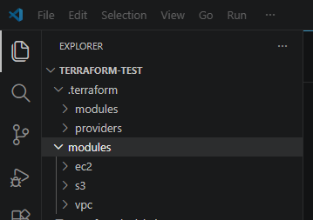
Inside your root project directory (terraform-project), create a file named:provider.tf
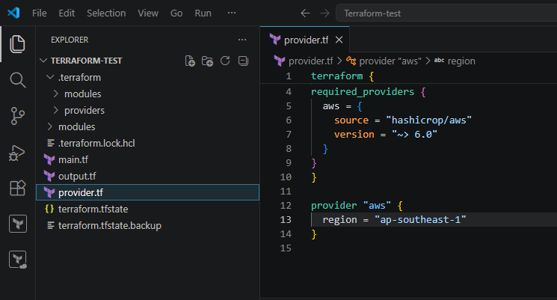
Why Do We Create provider.tf?
This file tells Terraform:
1. Which cloud provider to use (AWS)
2. Which AWS provider version to download
3. Which AWS region to deploy resources into
Terraform reads provider.tf and downloads the AWS provider plugin.
Now lets create files inside VPC folder:
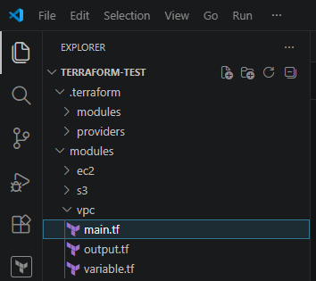
create variable.tf
variable "vpc_cidr" {
description = "CIDR block for VPC"
type = string
}
variable "subnet_cidr" {
description = "CIDR block for subnet"
type = string
}
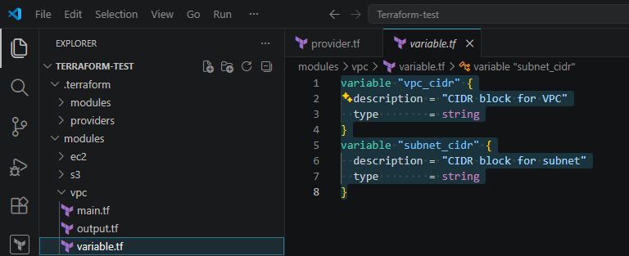
Create main.tf
resource "aws_vpc" "main" {
cidr_block = var.vpc_cidr

tags = {
Name = "terraform-vpc"
}
}

resource "aws_subnet" "public" {
vpc_id = aws_vpc.main.id
cidr_block = var.subnet_cidr
availability_zone = "ap-southeast-2c"

tags = {
Name = "public-subnet"
}
}
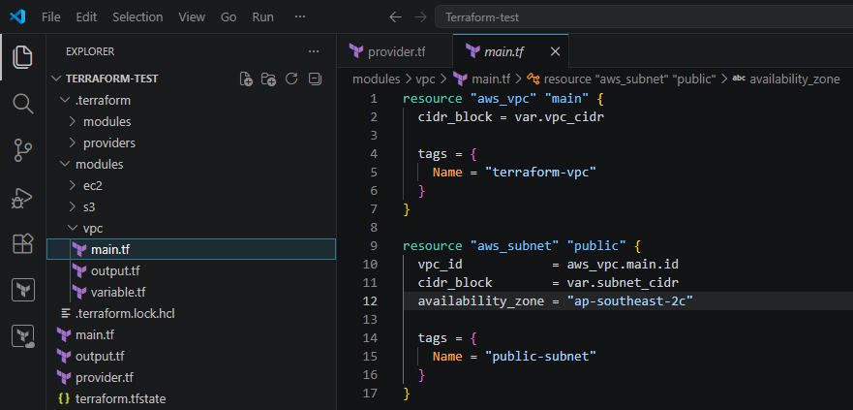
Create outputs.tf
output "vpc_id" {
value = aws_vpc.main.id
}
output "subnet_id" {
value = aws_subnet.public.id
}
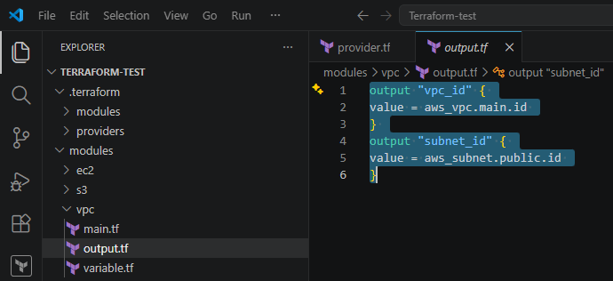
Lets create files inside ec2
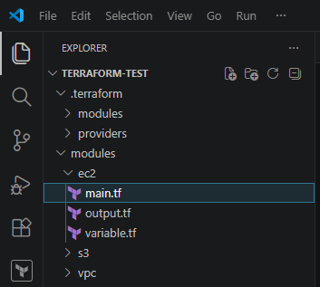
create variable.tf
variable "ami" {
description = "AMI ID for EC2 instance"
type = string
}

variable "instance_type" {
description = "EC2 instance type"
type = string
}

variable "subnet_id" {
description = "Subnet ID where EC2 will be launched"
type = string
}
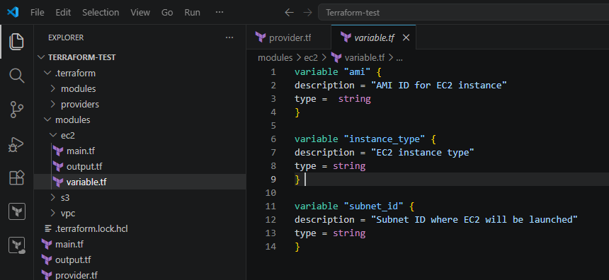
Create main.tf
resource "aws_instance" "web" {
ami = var.ami
instance_type = var.instance_type
subnet_id = var.subnet_id
tags = {
Name = "web-server"
}
}
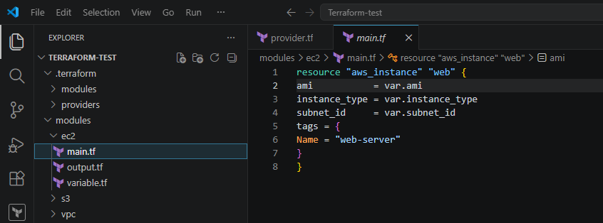
Create output.tf
output "instance_id" {
value = aws_instance.web.id
}
output "public_ip" {
value = aws_instance.web.public_ip
}
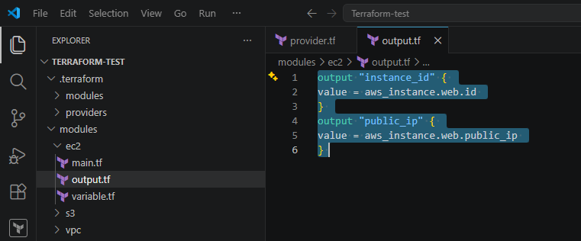
Now lets create s3 module
Create files inside s3 module
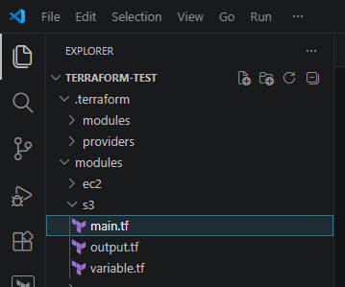
create variable.tf
variable "bucket_name" {
description = "Name of S3 bucket"
type = string
}
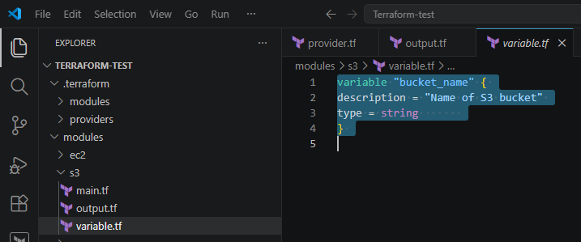
create main.tf
resource "aws_s3_bucket" "bucket" {
bucket = var.bucket_name
tags = {
Name = "terraform-bucket"
}
}
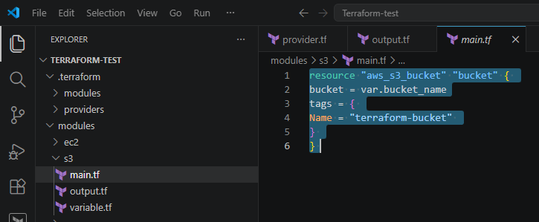
create output.tf
output "bucket_name" {
value = aws_s3_bucket.bucket.bucket
}
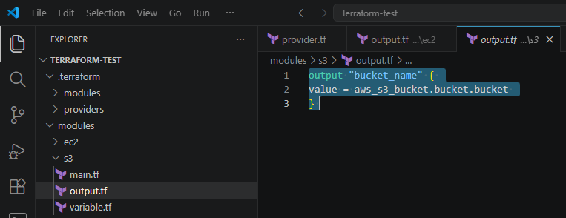
Now lets create main.tf file for root project
module "vpc" {
source = "./modules/vpc"
vpc_cidr = "10.0.0.0/16"
subnet_cidr = "10.0.1.0/24"
}
module "ec2" {
source = "./modules/ec2"
ami = "ami-0c78ef10ebf8c08db"
instance_type = "t3.micro"
subnet_id = module.vpc.subnet_id
}
module "s3" {
source = "./modules/s3"
# Change to a unique name
bucket_name = "mycompany-dev-bucket-987654"
}
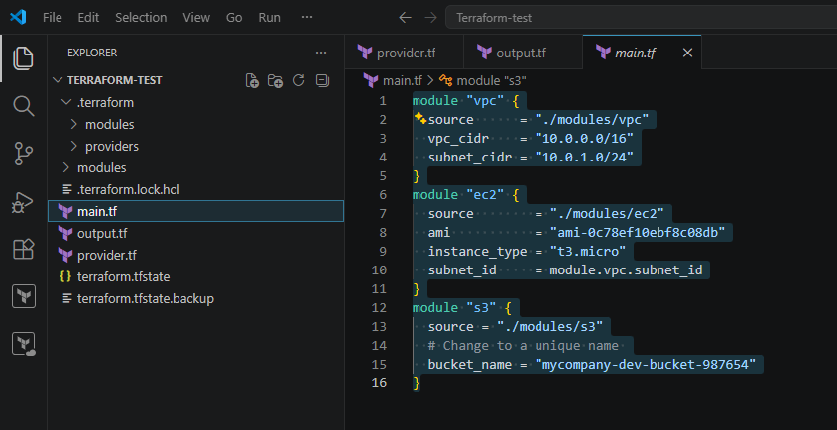
Now let’s create output.tf:
output "vpc_id" {
description = "VPC ID created by VPC module"
value = module.vpc.vpc_id
}

output "subnet_id" {
description = "Subnet ID created by VPC module"
value = module.vpc.subnet_id
}

output "instance_id" {
description = "EC2 Instance ID"
value = module.ec2.instance_id
}

output "public_ip" {
description = "Public IP of EC2 Instance"
value = module.ec2.public_ip
}

output "bucket_name" {
description = "S3 Bucket Name"
value = module.s3.bucket_name
}

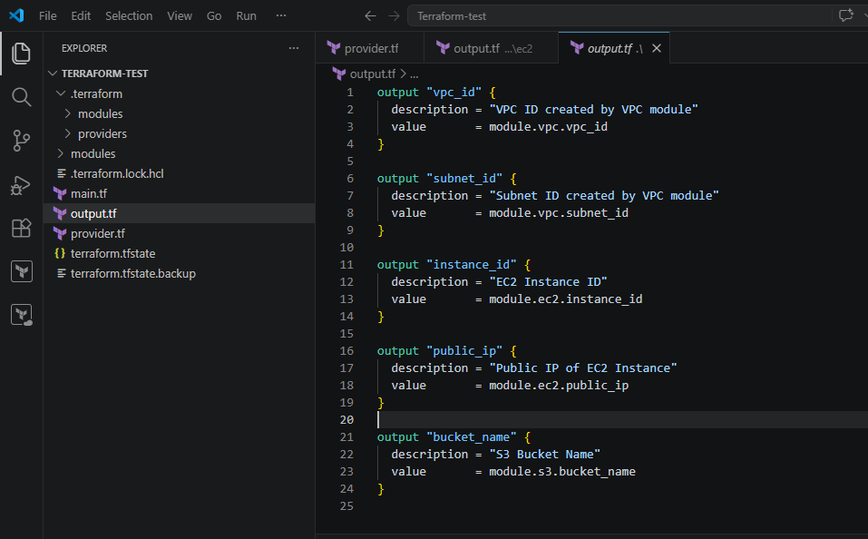
Initialize Terraform: 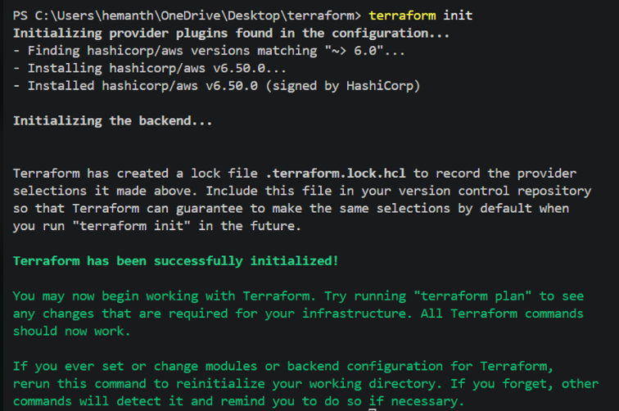
Validate configuration
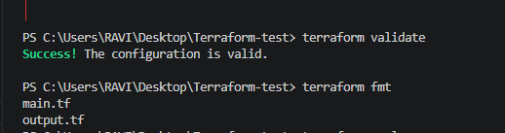
Terraform plan
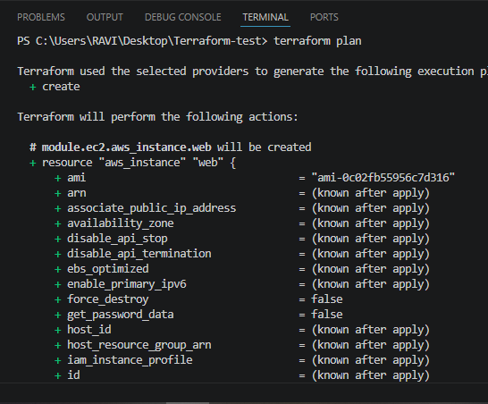
terraform apply:
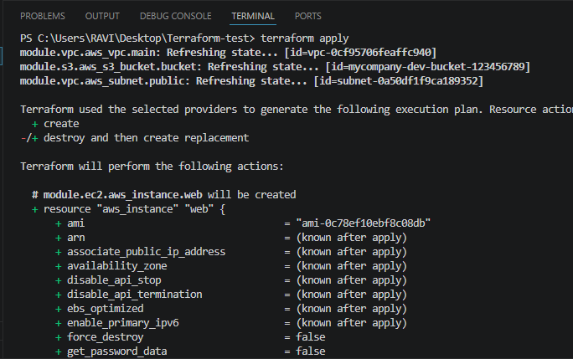
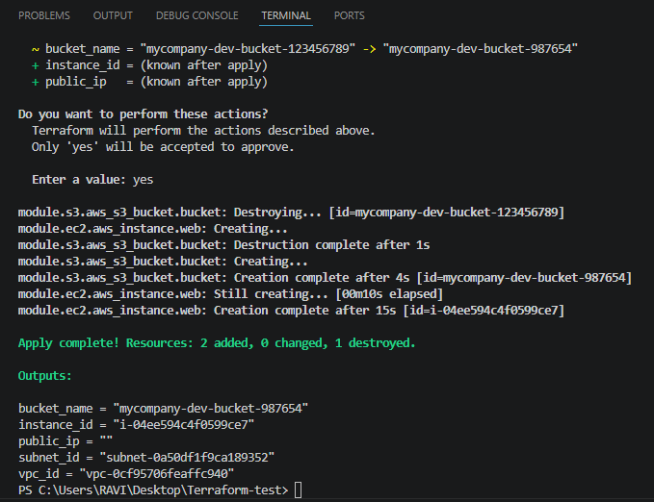
Instance created successfully
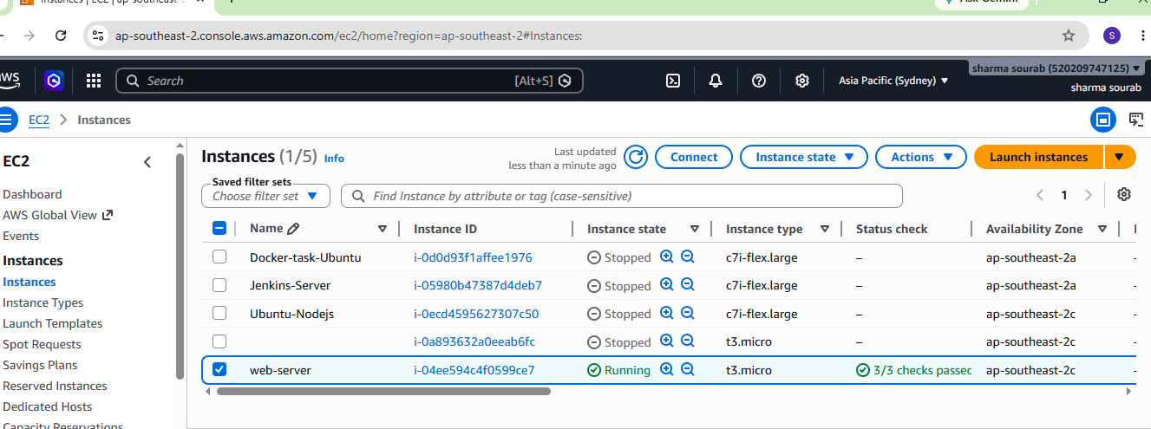
S3 bucket created successfully
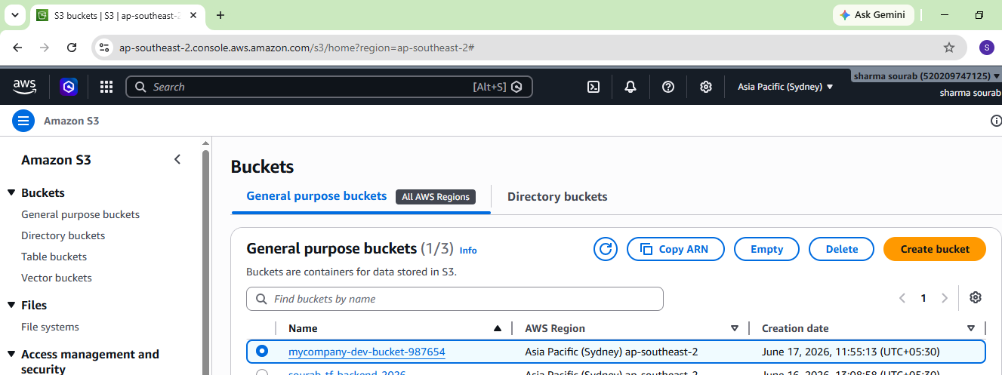
VPC created successfully
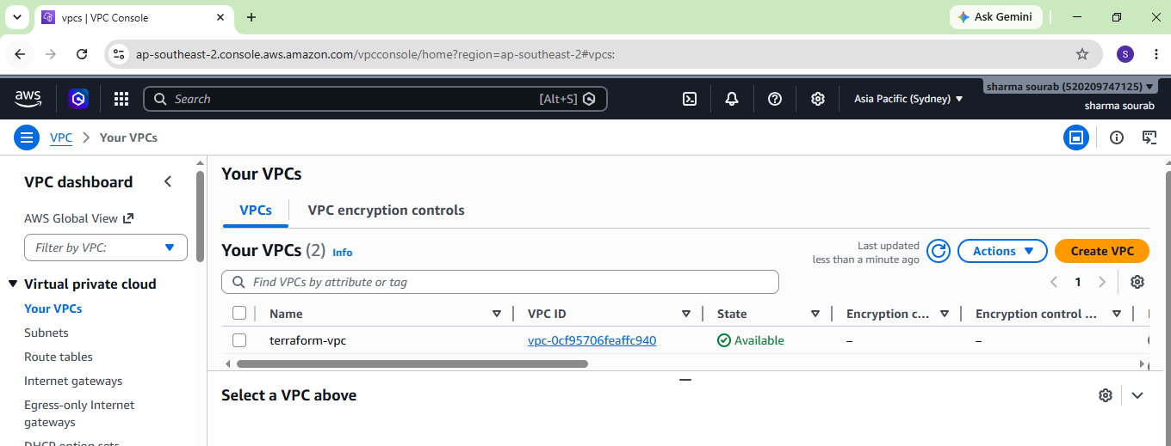
4). Provision EC2 for 3 different environments (Dev, Staging, and Prod) using Terraform workspaces.
Lets create terraform-workspace folder
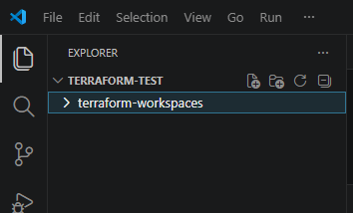
Lets create provider.tf file
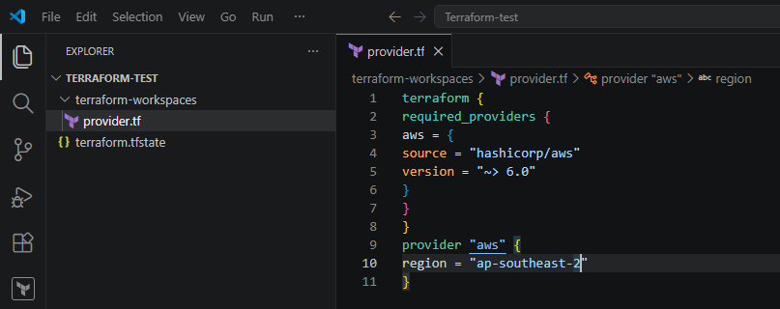
Lets create variable.tf
Here we define different AMIs and instance types for each environment.
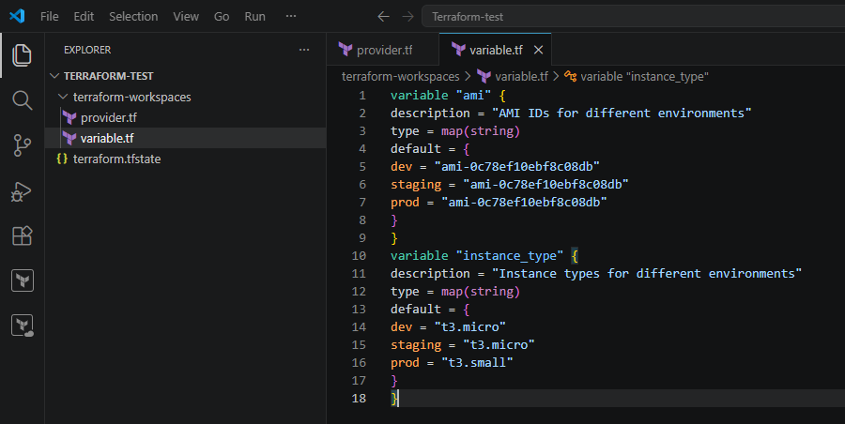
Create main.tf
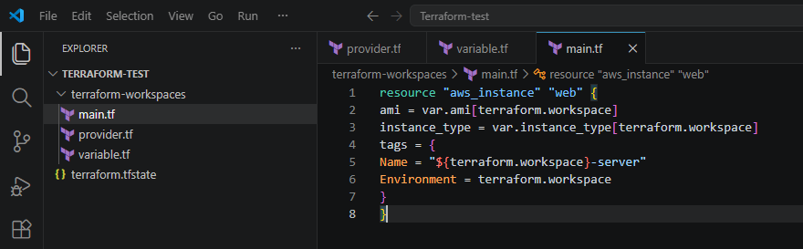
Create outputs.tf
output "instance_id" {
value = aws_instance.web.id
}

output "public_ip" {
value = aws_instance.web.public_ip
}

output "Environment" {
value = terraform.workspace
}
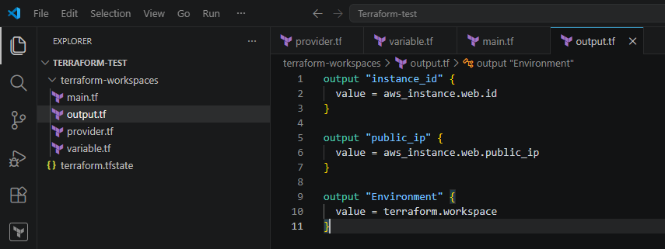
Run terraform init
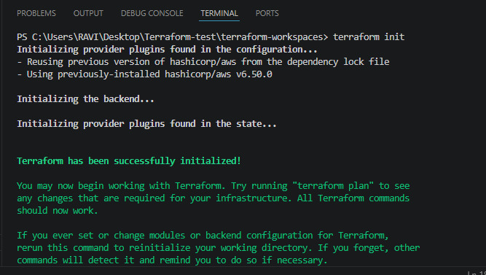
Create the below workspaces
- Dev workspace
terraform workspace new dev
- Staging workspace
terraform workspace new staging
- Prod workspace
terraform workspace new prod
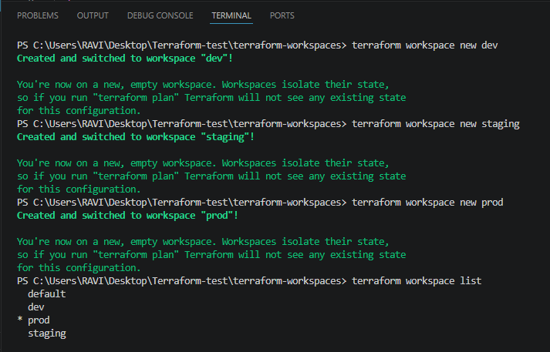
Switch to Dev
terraform workspace select dev
terraform workspace show – To show the current workspace 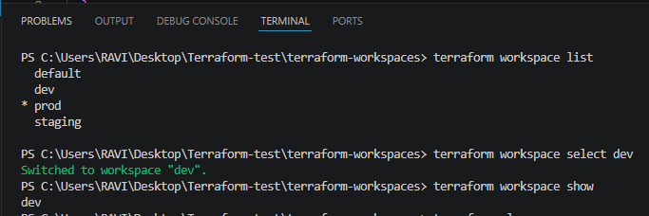
Terraform init:
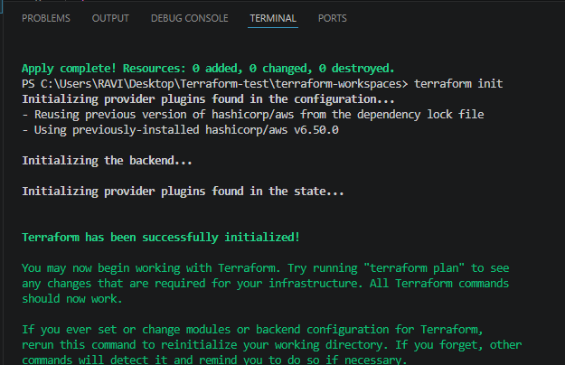
terraform plan:
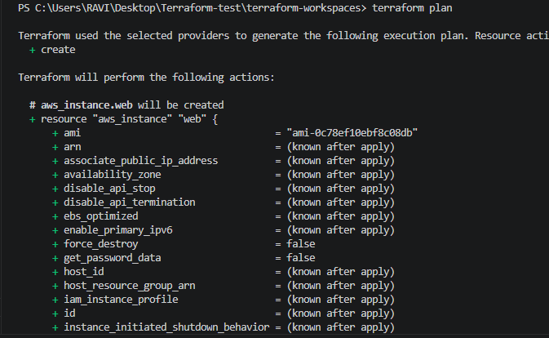
terraform apply:
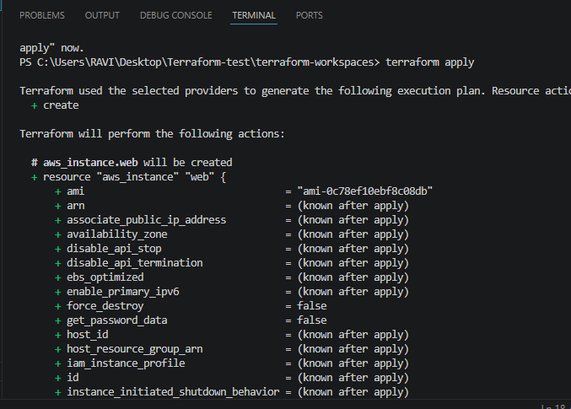
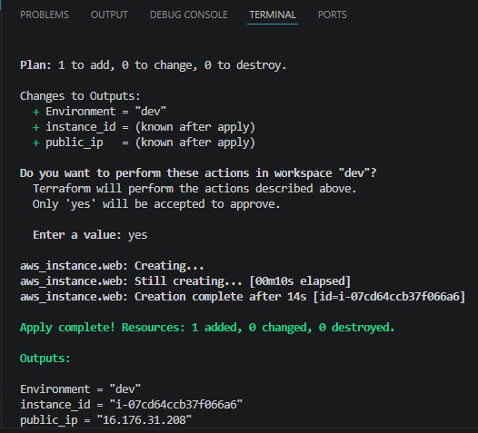
Lets switch to staging environment
terraform workspace select staging and then terraform init:
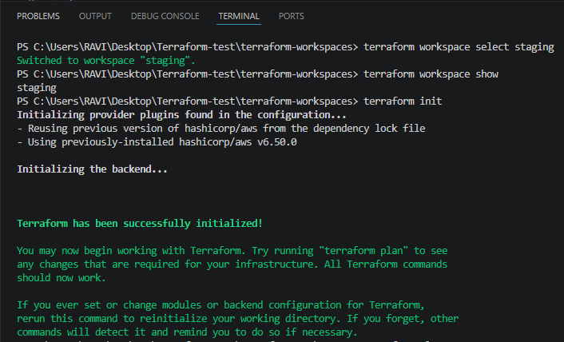
terraform plan: 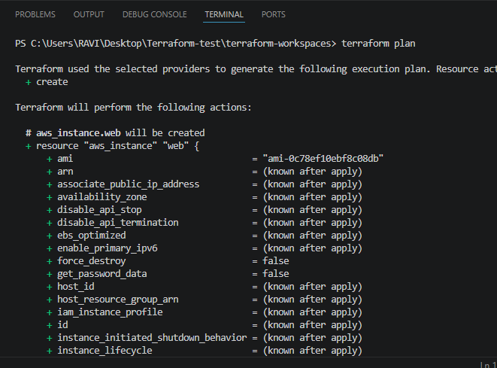
Lets create staging ec2 instance
Terraform apply
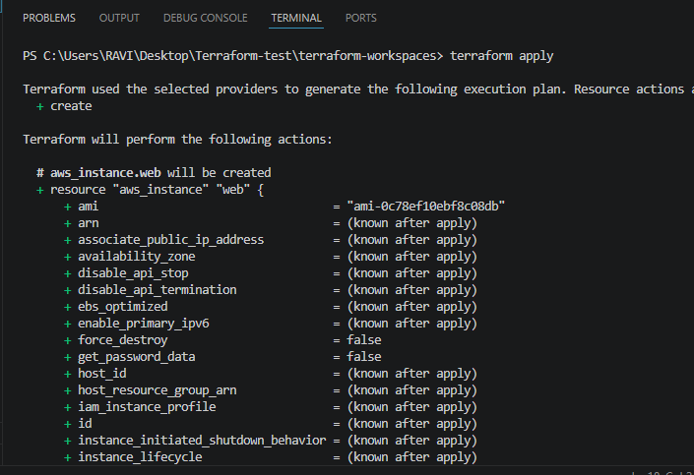
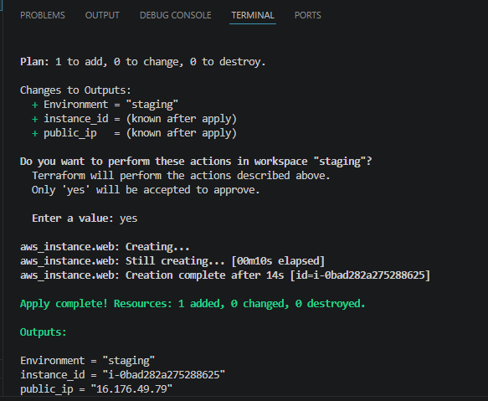
Now lets switch to prod environment
terraform workspace select prod and then terraform init:
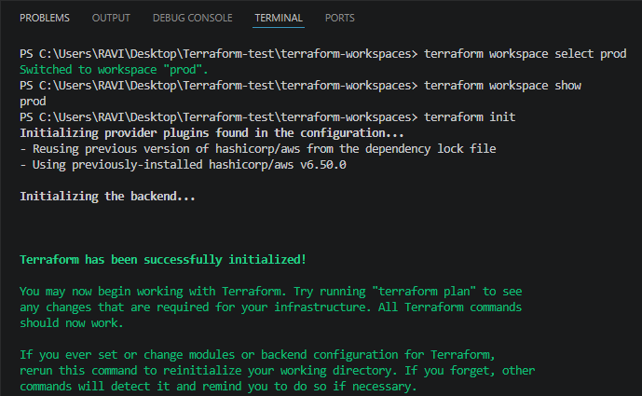
terraform plan:
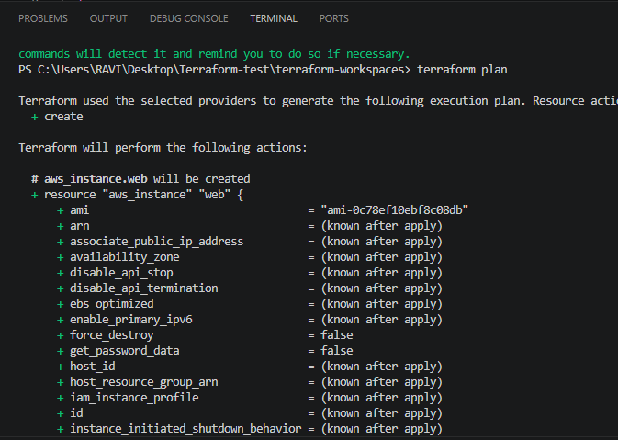
terraform apply:
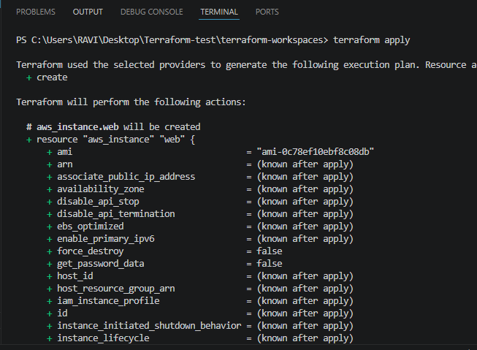
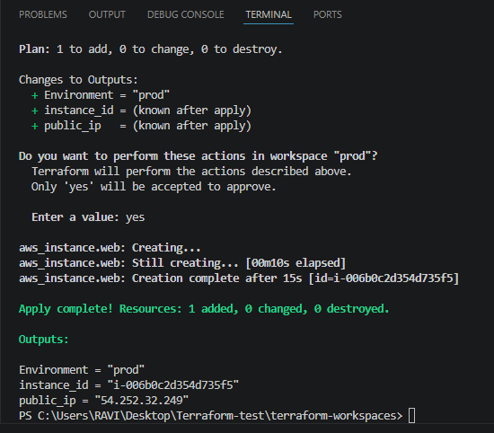
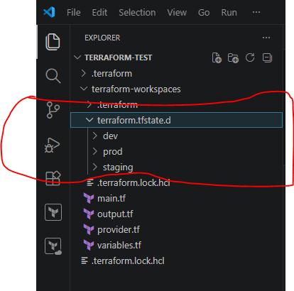
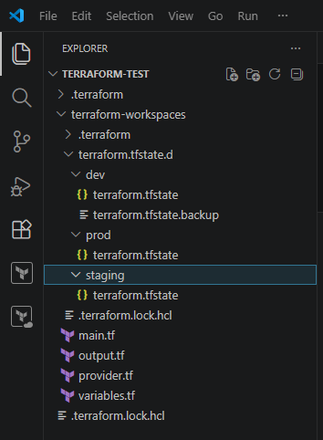
Instances created successfully
